Towards a Just and Lasting Peace
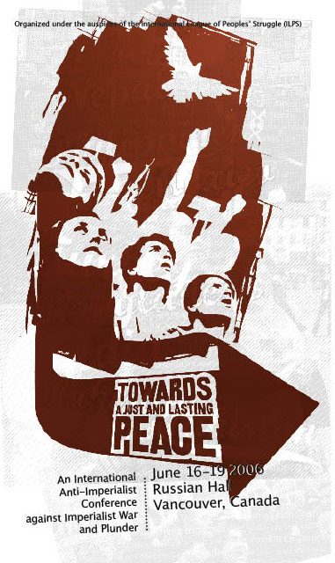

An international anti-imperialist conference against imperialist war and plunder
June 16-19, 2006 | Russian Hall (600 Campbell Street) | Vancouver | Canada
______________________________________________________________________________
Registration Form
Name _________________________________________________________
Organization (if any) ______________________________________________
Please describe your organization: ____________________________________
______________________________________________________________
Address: _______________________________________________________
Phone: ____________________________ Email: _______________________
Country: ___________________________ Fax Number: __________________

Will you need childcare? ___________________________________________
If yes, please specify age of children: __________________________________
Do you have any translation needs? ___________________________________
If yes, please specify: ______________________________________________
Do you have any physical accessibility needs? ____________________________
If yes, please specify: _______________________________________________
Do you have any special food needs? ___________________________________
If yes, please specify: _______________________________________________
Can you billet conference delegates in Vancouver? _________________________
On which nights can you billet? (please circle)
June 15 June 16 June 17 June 18 June 19 June 20 June 21
How many people can you billet? ______________________________________
Do you need to be billeted or will you make other arrangements? _______________
If you want to be billeted, please specify which nights:
June 15 June 16 June 17 June 18 June 19 June 20 June 21
If you want to be billeted, do you have any special needs?_____________________
________________________________________________________________
If you are not requesting billeting, do you need information about local accommodation?

Please provide your travel itinerary to and from the conference:
Arrival (date, day, time, flight no. departure point): _____________________
________________________________________________________________
Departure (date, day, time, flight no., destination): _______________________

Please return this form with payment by May 26, 2005. (No billeting or transportation will be provided for those registering after this date.) Registration fee will cover conference entrance, food during the conference, conference package, and will help to sponsor delegates from the south. Registration fee is Cdn$125 / US$115. Prepayment is required and can be made by cheque or money order payable to “BC Committee for Human Rights in the Philippines.” Payment can be sent to the ILPS in Canada c/o 451 Powell Street, Vancouver, BC, Canada, V6A 1G7. For more information contact ILPS in Canada at Phone: (604) 215-1905 or by email: ilps_canada@shawcable.com.

